**The Sandbox Review: A In-depth Look into the Meta-Community**

# **Introduction**

The World Wide Web has been a part of culture since its emergence in the late 1990s and has since overgone many changes, updates, and facelifts. As we loom upon Web3, so does the new dawn in the reaches that technology has and the opportunities inspired by this latest facelift. The Sandbox, a virtual Metaverse that lives within the new web 3.0, brings with it a heap of new opportunities we will explore in-depth in this Sandbox game review and guide.

The Sandbox is a wild-wild west kind of gameplay-focused frontier, with major partners ranging from Snoop Dogg, Atari & Adidas to Samsung and Coincheck, The Sandbox is a community-metaverse started on and powered by the blockchain. Here, the virtual LANDs, ASSETs, and businesses to NFT museums and 24/7 discos, the Sandbox game creates a rich opportunity cost to live out all the creative dreams you have ever had.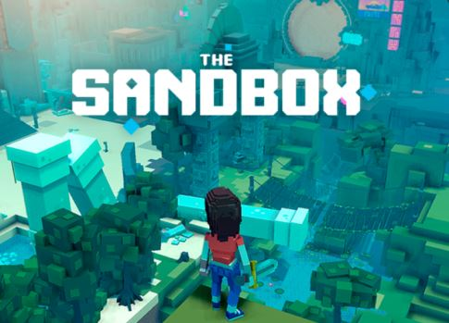

# **What is the Sandbox?**

The Sandbox is the best evolution of social media, moving from the adoration-driven models to one that people can truly create another life on in this gaming ecosystem. The Sandbox game is a community-driven, decentralized platform existing on the Ethereum blockchain and a space where users can own land, assets, or complete experiences as a character. One can make create and play games with features like Game Maker or get paid to create and share the creations you’ve made with the Game Maker Fund.

The Sandbox also allows you to buy NFT land and monetize on it, whether it’s through hosting contests to voting in the Metaverse governance, or even staking SAND, the native coin to the Sandbox game. With only 166,464 available plots of land, the price is rising quickly as Sandbox takes on a life of its own, built for creators, by creators through 100% user-generated content.

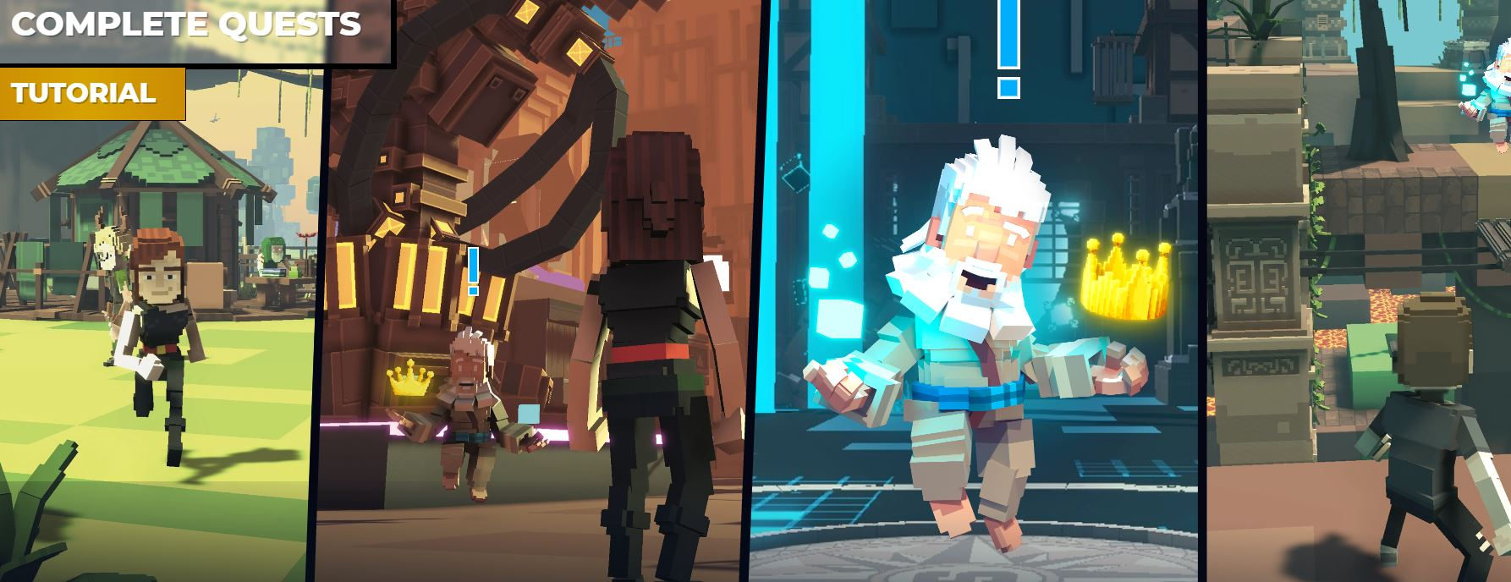

# **How to Play the Sandbox**

Sandbox is relatively simple to access; First, you’ll need to create a Sandbox account from [sandbox.game](http://sandbox.game) on the blockchain. User profiles are created through your browser wallet, such as Metamask, then enter your email and create a password, before downloading the zip file, unpacking, and installing the game’s platform onto your computer, which should take up 300 MB. Within your profile on the site, you can customize your avatar, browse LAND available for sale and explore the many creator tools available.

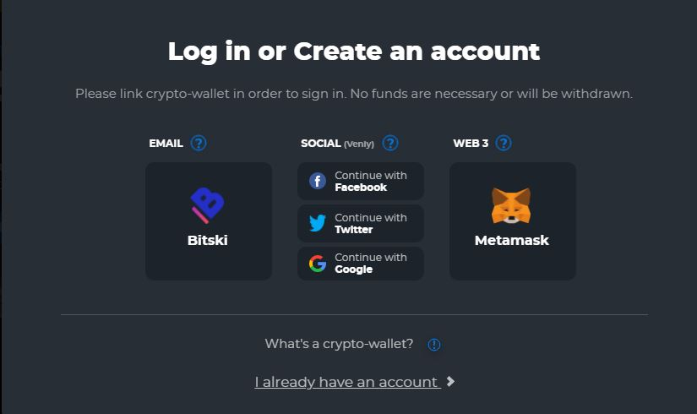

5000 alpha passes were distributed through a rewards system prior to and during the Alpha launch, giving the owner access to all 18 initially available experiences. If you did not get an Alpha pass, you were still able to access 3 of these platforms. The Alpha phase went from November 29th, 2021 until December 20th, 2021; we are now in the between time until season 2 comes out.

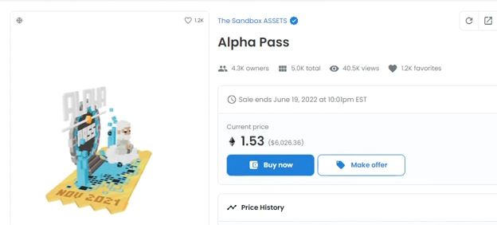

# **How does the Sandbox work?**

Currently, the Sandbox beta has concluded, so it's unavailable to access but with Alpha season 2 making its way to market, let’s get you prepared. The idea of The Sandbox is a community-driven space to help fuel the creators while simultaneously rewarding the players and contributors, in fact over 5 million SAND was rewarded during season 1 alone! Exclusive NFT collections including Snoop Dogg, The Walking Dead, Smurfs, and Deadmau5 all call the Sandbox home, a legit list of both status and money.

The Sandbox game is also a place for creators to thrive, allowing game makers to create free 3D games. The VoxEdit features also allow for a lot of control with the world, which can generate anything from people (NPCs) to animals, tools, and randomized objects. The Sandbox is essentially a place for everyone in the Metaverse to easily collaborate, sell, create and purchase NFTs, ASSETs, and LANDs.

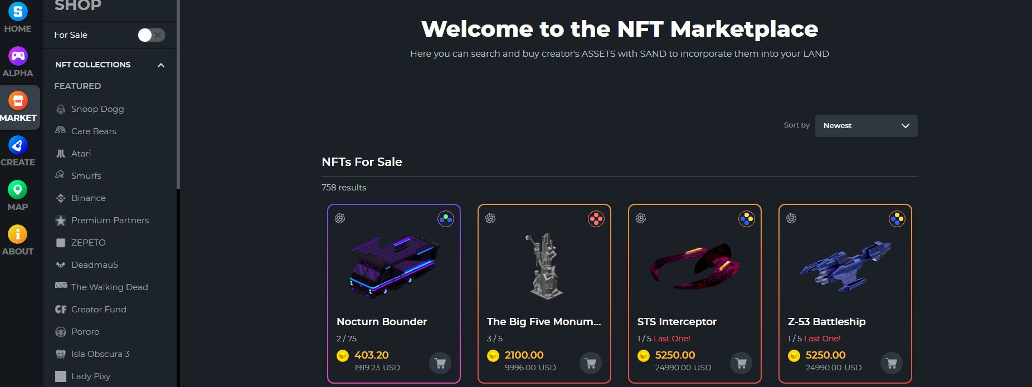

# **How to make money on the Sandbox**

In the Sandbox ecosystem, creating income can be done in a variety of ways, paying the native token, SAND. You can design and profit from your own 3D games made possible with the Sandbox Game Maker or play premade ones ending with rewards. Any owned LAND can be rented to other players; use ASSETS to colonize it and increase its value, it may even make the Community news!

You can also create ASSETS with the VoxEdit feature and then upload them to the marketplace as NFTs. These can be many things from cars to animals to bikes and the income from them can range from a few SAND tokens to a few thousand SAND tokens. Ever forward-thinking, the ecosystem pays for all the Ethereum gas fees on behalf of the users, while 50% of the transaction volume is routed to The Sandbox Foundation, a promotor, and grantor for the metaverse.

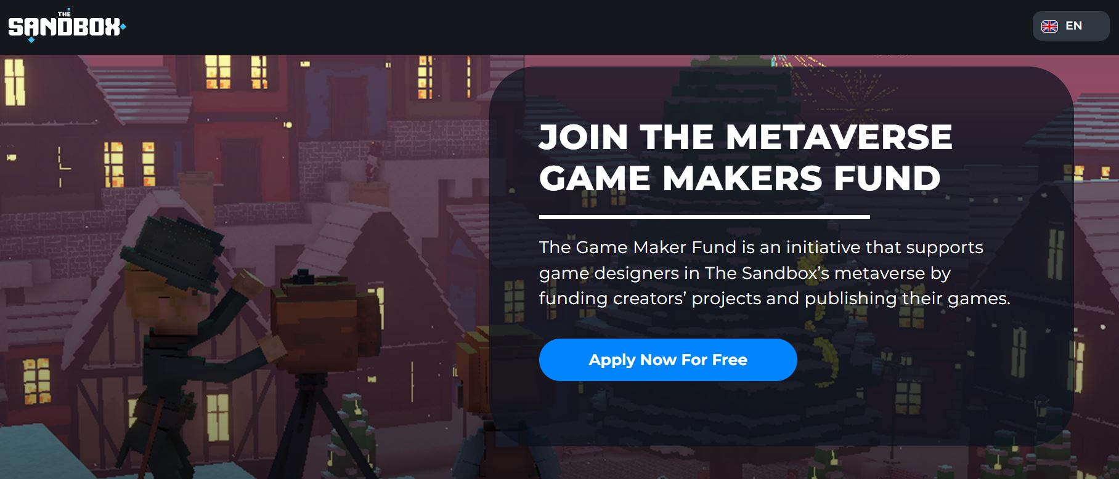

**How much can you earn on the Sandbox?**

The potential of earnings in the Sandbox is at a virtually limitless ceiling, all pun intended. If you happened to grab one of the 5000 Alpha passes being sold off prior the November 27th, you would’ve had full access to the 18 experiences and thus, would have put you in the top-earning category, with an Alpha pass, playing earns you both SAND and NFTs split between 5 levels of rewards.

Using the Sandbox launcher downloaded from the main site, you can find a guru who will give you quests to complete. You are primarily driven by recognizing and finding places and items throughout those experiences and quests. The more you complete, the more your level grows and the larger reward you get. Each experience hosts its own guru, objectives, and earning potential; and by the end of level 5, I earned 1000 SAND & 3 NFTs, worth maybe 0.025 ETH.

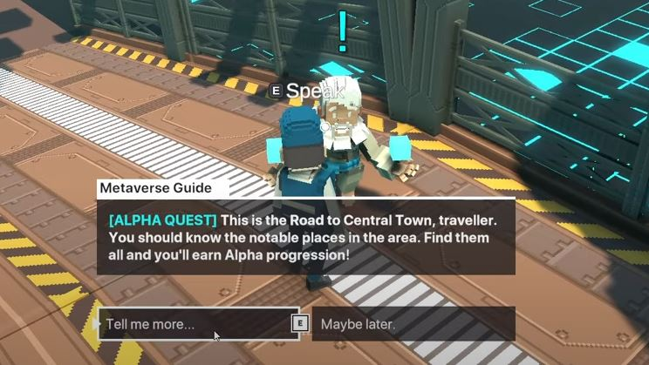

**Conclusion**

As Web3 begins to take hold of the internet’s future, creative-driven, decentralized communities will undoubtedly start sprouting across the Metaverse planes. Groundbreaking marketplaces like The Sandbox have already carved their way into the foreseeable future, allowing players and creators to continue promoting a symbiotic myriad of experiences, in the way that crypto as a whole has spurred a brand-new class of economists and entrepreneurs alike.

My prediction is we may have the Sandbox on our iOS iPhones, Android, and other mobile devices, enabling us to play and earn no matter where we are in the world, virtual Meta’s like The Sandbox can keep us forever connected. The idea is simple yet elegant, reward players to play, reward creators to create, and encourage LAND owners to make the most out of their investment; The Sandbox is a place where all, truly is one and where we all, are for each other.

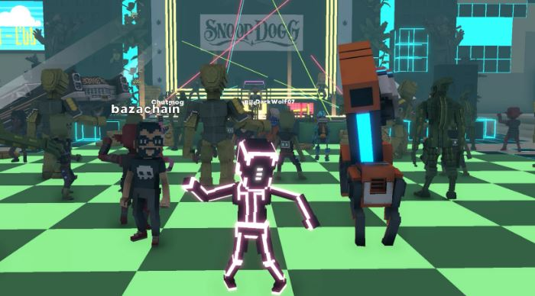

# 

# 

# Sources

**BORGET, S.**

The Sandbox (SAND): Tokenized Assets for Gaming Ecosystems

**In-text:** (Borget, 2021)

**Your Bibliography:** Borget, S., 2021. *The Sandbox (SAND): Tokenized Assets for Gaming Ecosystems*. [online] Cryptopedia. Available at: <https://www.gemini.com/cryptopedia/the-sandbox-sand-crypto-nft-virtual-world> [Accessed 9 February 2022].

**https://www.sandbox.game/en/about/**